## Steps to designing your own circuit board

### Before starting the design

* Find your libraries. These will be *.lbr files and can be found in a variety of places like GitHub. Libraries consist of user designed modules, using them means you don’t have design each on board component yourself, making the whole process much simpler.
* They should be saved inside the libraries folder of your Eagle program (usually inside C:\Documents\EAGLE\libraries)
* 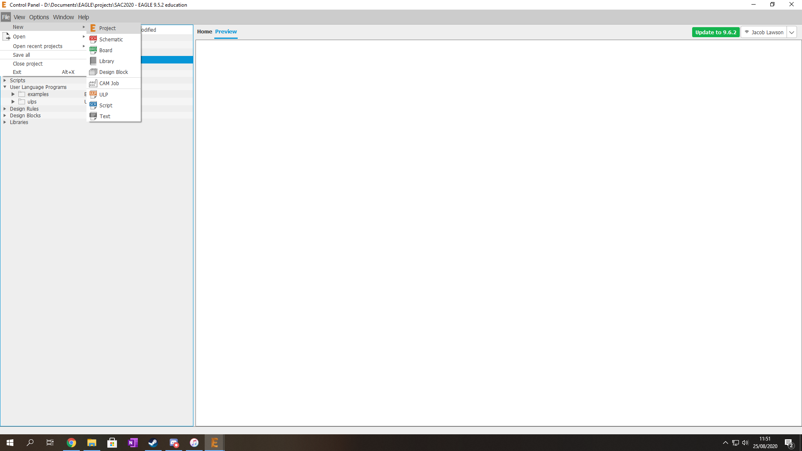If you’re working in a group project, then using Autodesk’s library.io will allow many users to easier share the libraries that hey find. SunrIde VENSA has a library.io that the avionics team shares.

### Now you can start a new project

* Open Eagle and you will be presented with the central control panel.
  + File -> New -> Project
* 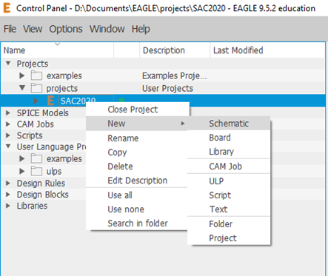Then right click on this new project and select;
  + New -> Schematic

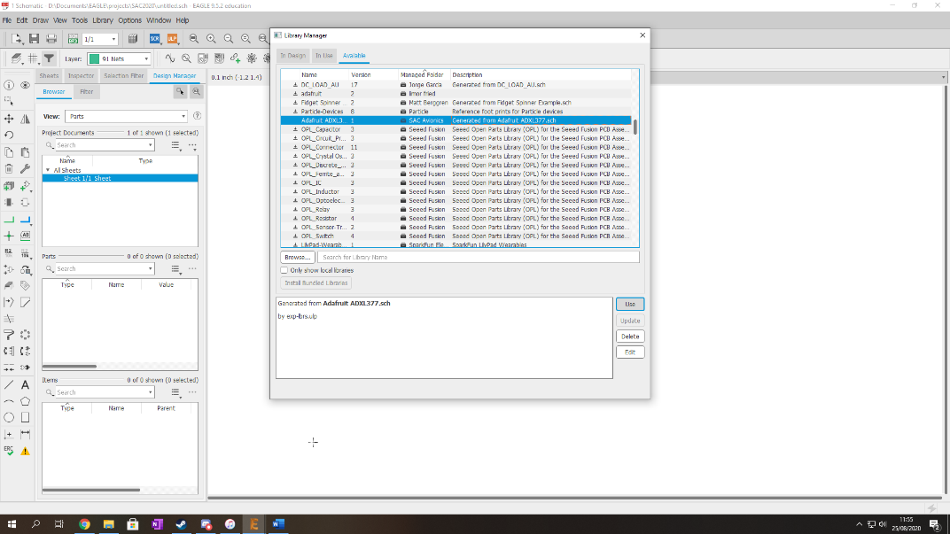

* The first thing you should do is include the libraries that you have found
  + Library -> Library Manager -> Available -> Select USE
* Then you need to place a boarder to place your schematic inside
  + Add -> frame -> A4L – LOC -> OK -> place -> ESC -> ESC

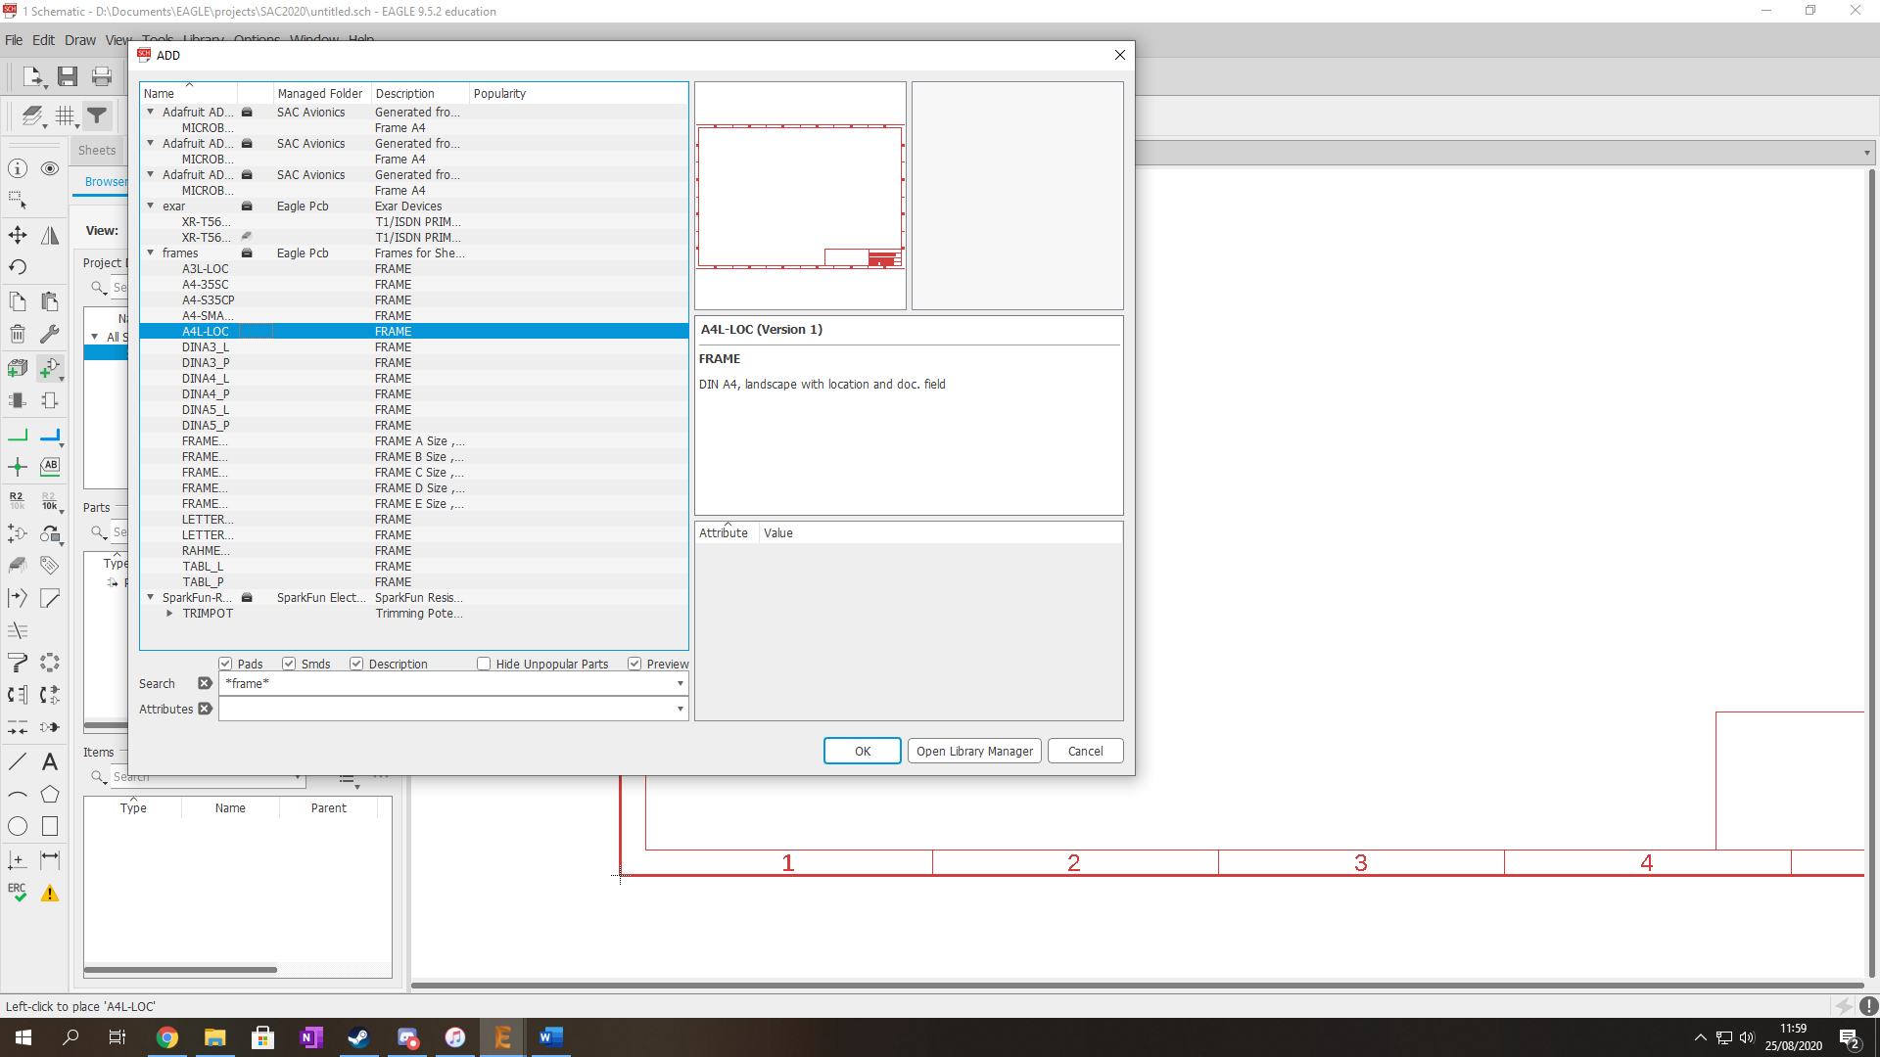

* Now bring in the parts that you need
  + Teensy – 3.6_Only_Holes
  + LED5MM 4 single colour LEDS
  + R 4 resistors
  + 163 2 ADXL accelerometers
  + 35701331 2 relay
  + PINHD-1X2 2 1x2 pinheads
  + 1N4004 2 diodes
* Now you can go ahead and do all the GND pins
  + Add Part -> search GND -> sparkfun GND
* Then add the 5V pins
  + Add Part -> search 5V -> sparkfun 5V
* Then add the 3.3V pins
  + Add Part -> search 3.3V -> sparkfun 3.3V
* The pin named 3V3(Max_250MillaA) also needs a 3.3V connection, but in series with a resistor to limit the current. V/I = R gives 13.2 Ohms, the closest spec resistor in 15 Ohms.

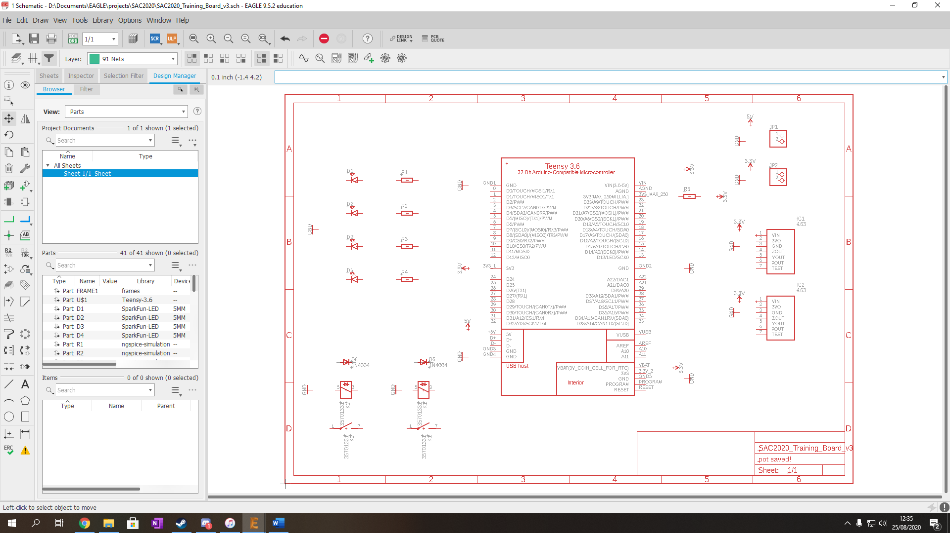

* Now you can label the resistor using the Value tool on the left hand side
* Select each of the LED resistors and add the value 220 Ohms
* Then select the resistor connected to 3V3(Max_250) and give it the value of 15 Ohms
* Now you can connect up your schematic using the Net tool

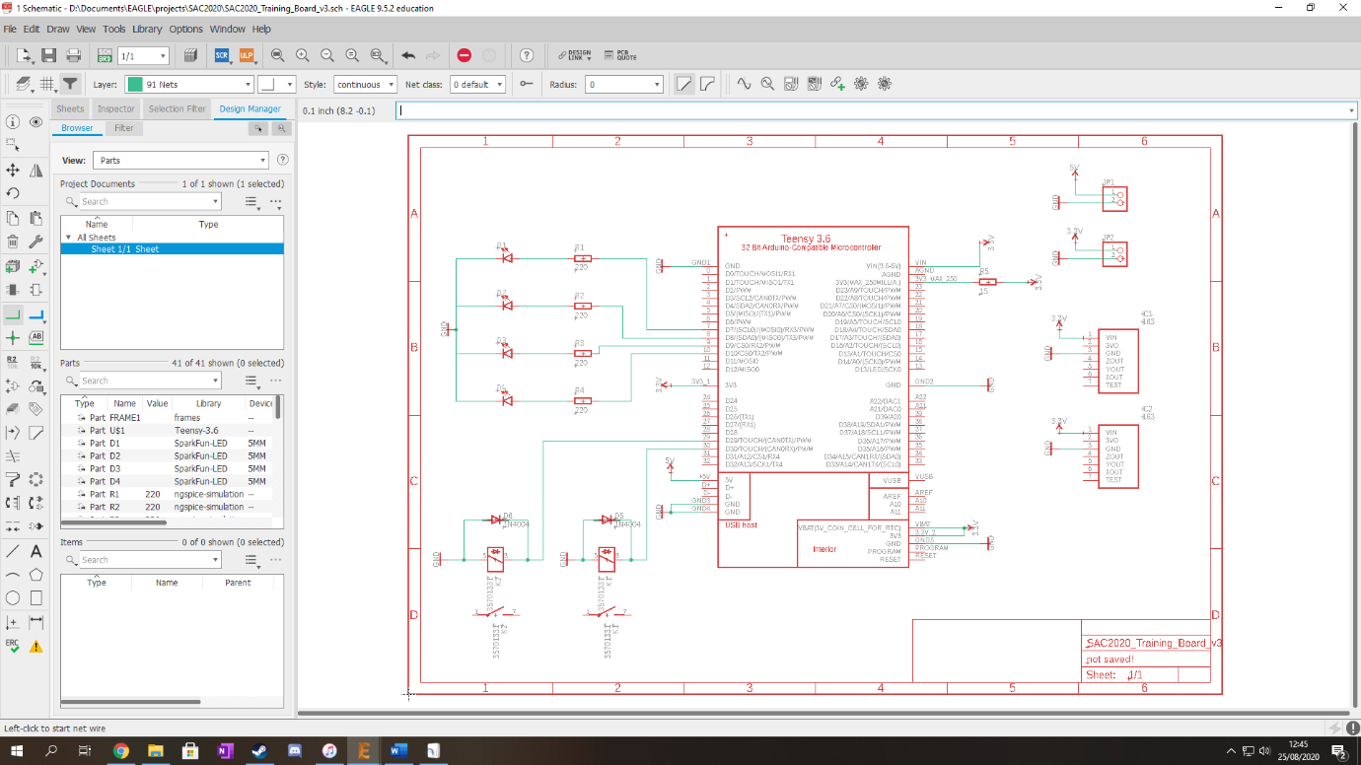

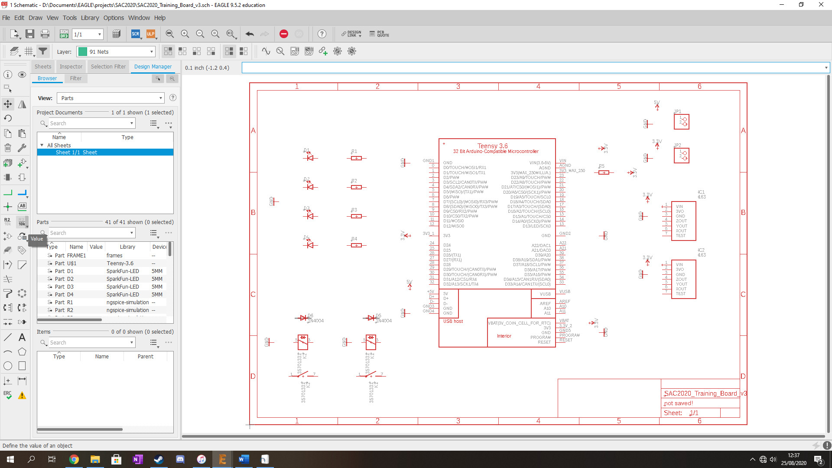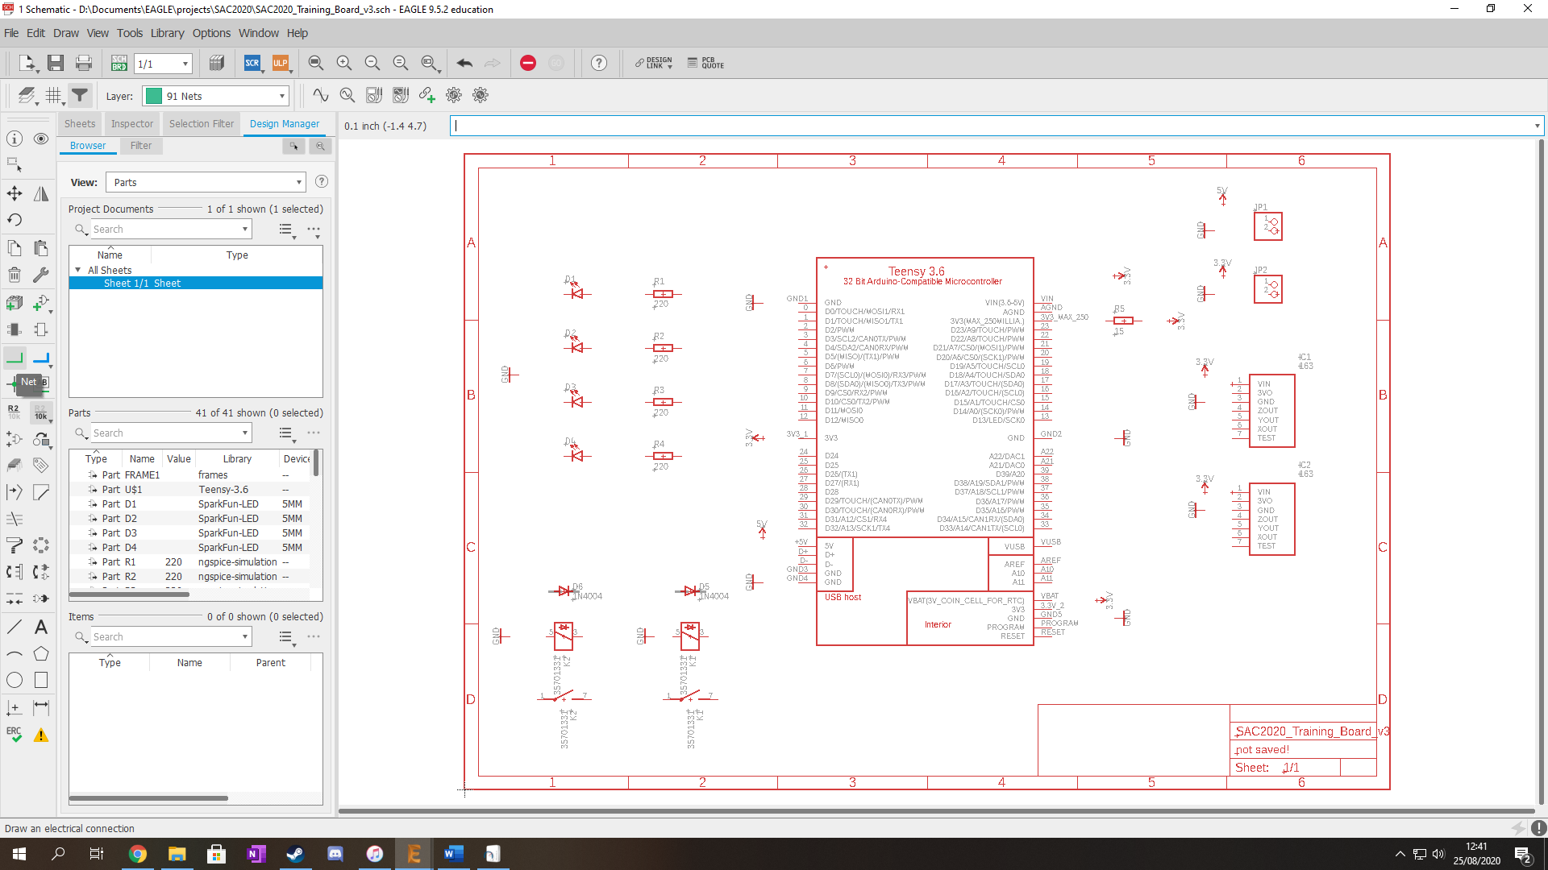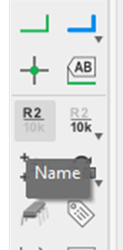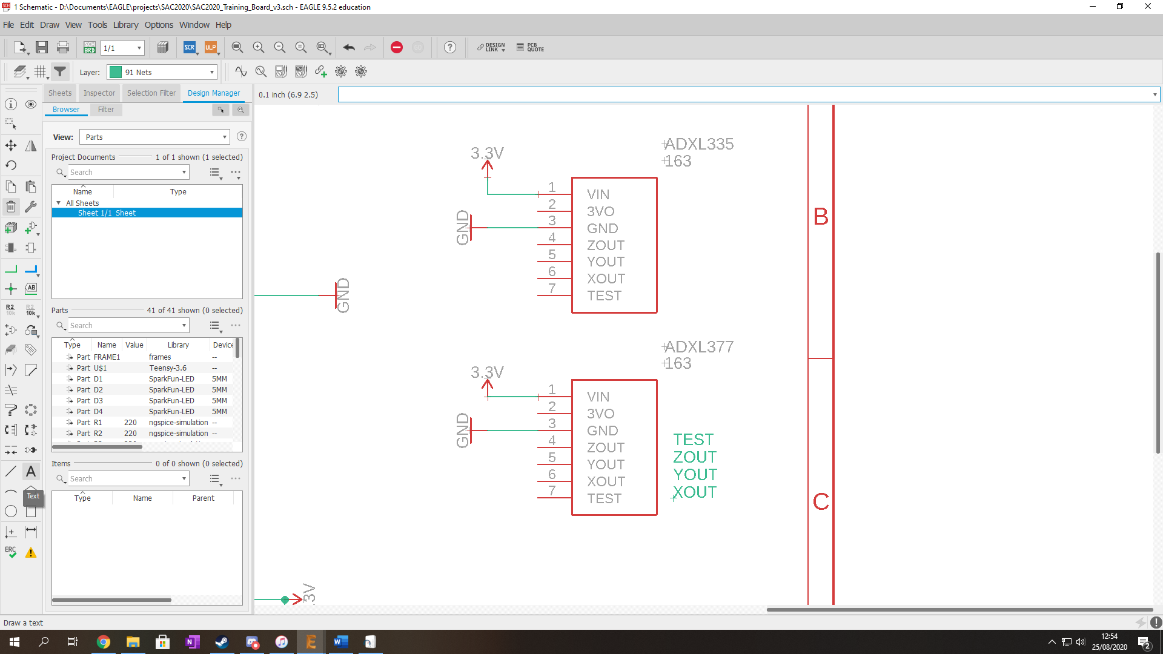

* I’ve left the ADXL accelerometers unconnected as one of them must be renamed to ADXL377 which has a slightly different pin layout
* So, using the Name tool add the name ADXL377 to on accelerometer and ADXL335 to the other

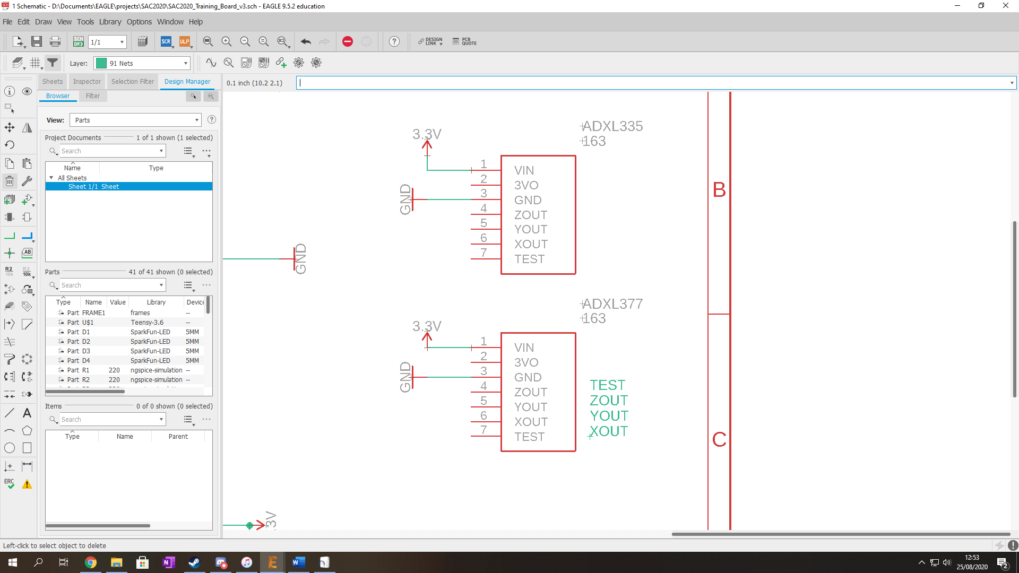

* Now you can wire up both the accelerometers

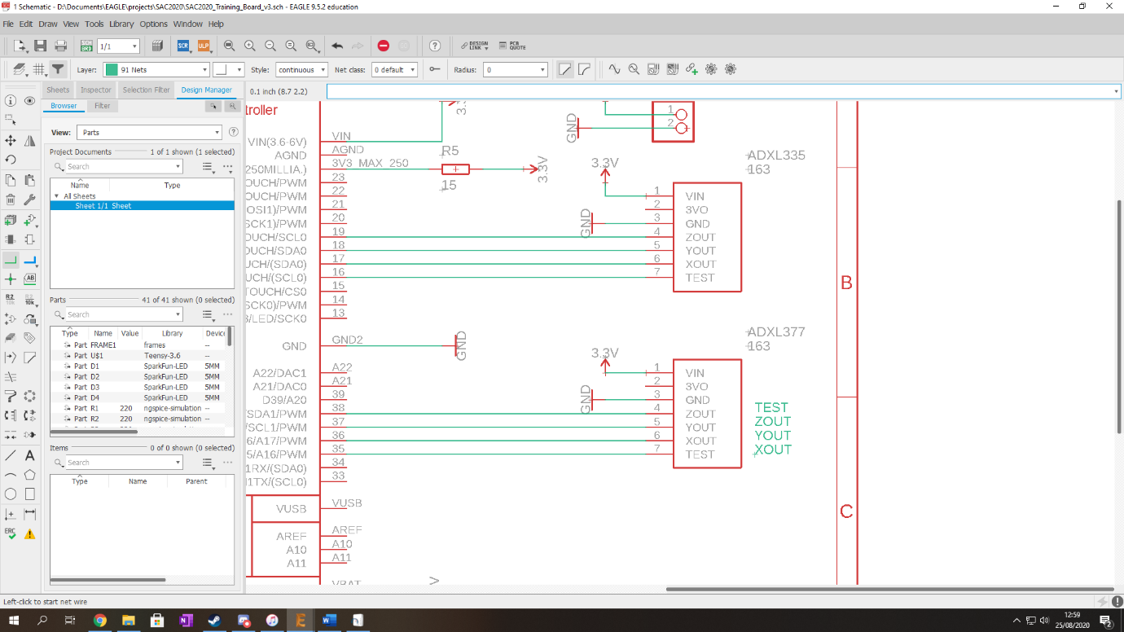

* The last thing to do is connect and name the relay outputs. To do this simply create net lines out of each side of the switches and add names.
  + VBIN to the side with 1 above it
  + VBOUT to the side with 7 above it

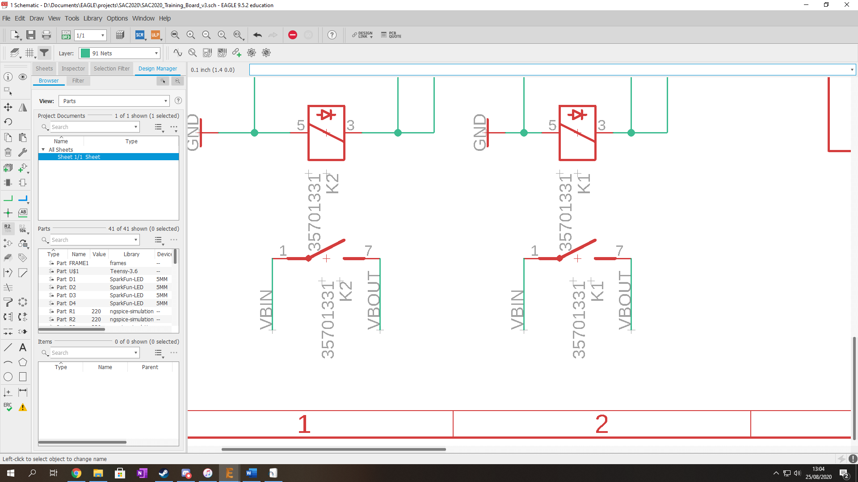

# And now your schematic is finished